**ATTRIBUTE EXPLORATION FOR GREMAN CREDIT DATASET**

1. List of attributes and their types:

* Credit_history – Nominal
* Purpose – Nominal
* Credit_amount – Numeric
* Serving_status – Nominal
* Employment – Nominal
* Istallment_commitment – Numeric
* Personal_status – Nominal
* Other_parties – Nominal
* Residence_since – Numeric
* Property_magnitude – Nominal
* Age – Numeric
* Duration – Numeric
* Housing – Nominal
* Exizting_credits – Numeric
* Job – Nominal
* Other_payment_plans – Nominal
* Checking_status – Nominal
* Num_dependents – Numeric
* Own_telephone – Nominal
* Foreign_worker – Nominal
* Class – Nominal

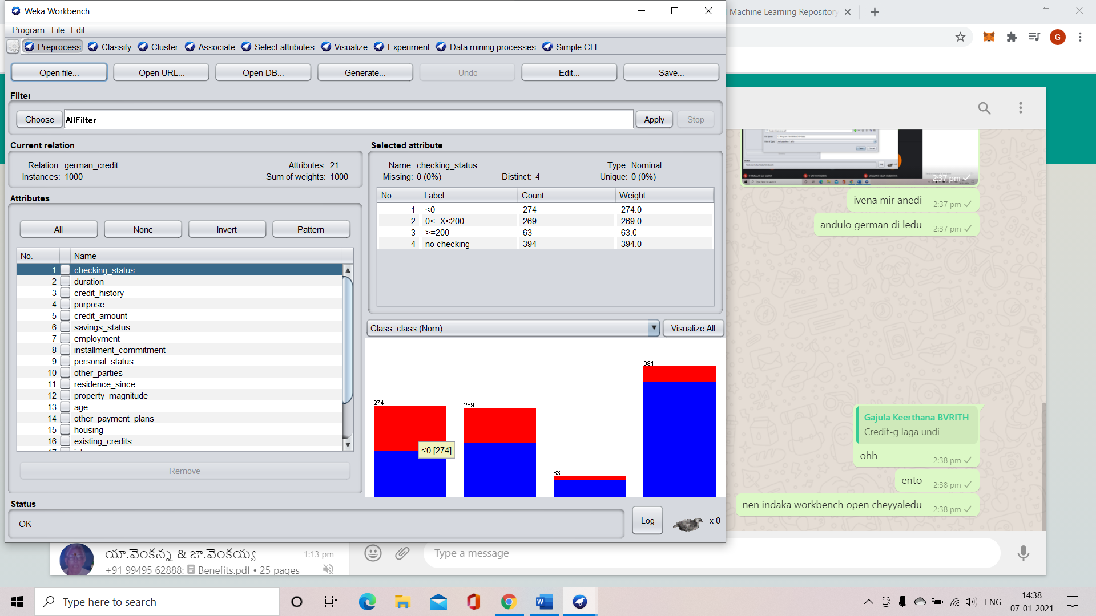 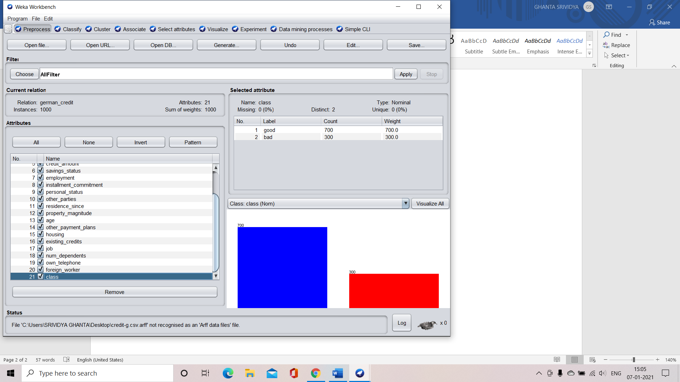

1. Number of attributes in the data set : 21

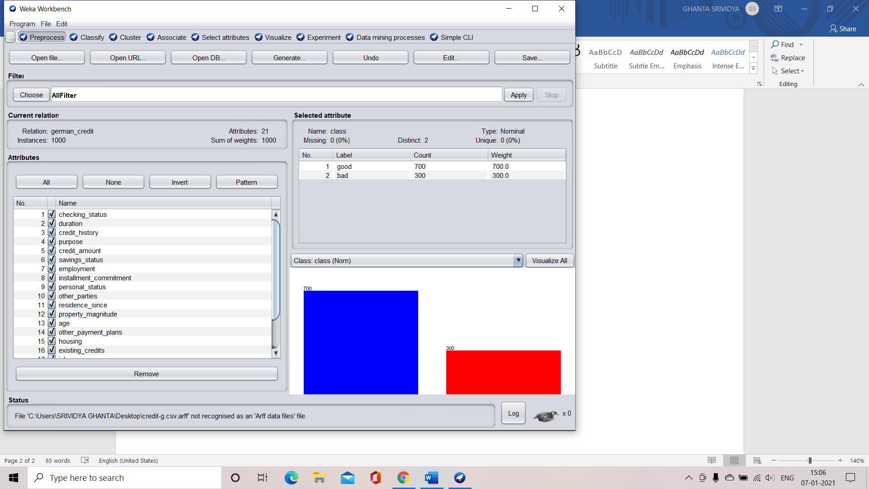

1. Number of records in the dataset : 1000



1. Class attribute in the dataset : class

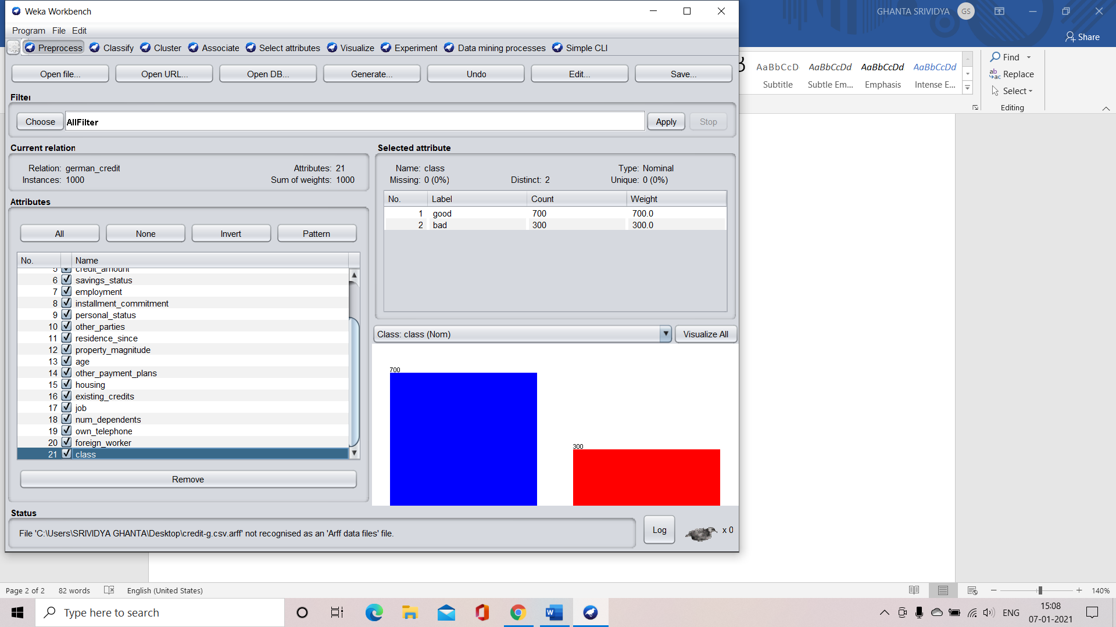

1. Number of attributes for each class:

* Good – 700 records
* Bad – 300 records



1. Graphical representation of all attributes against class attribute

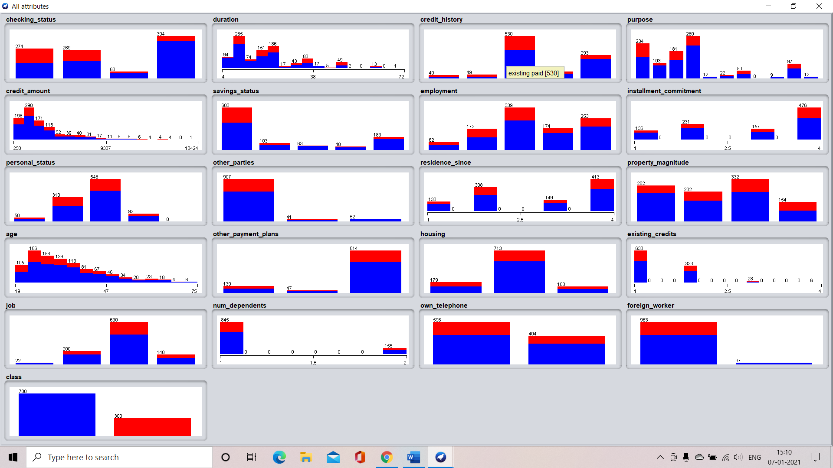

**ATTRIBUTE EXPLORATION FOR IRIS DATASET**

1. List of attributes and their types:

* Sepalwidth – Numeric
* Petalwidth – Numeric
* Class – Nominal
* Petallength – Numeric
* Sepallength – Numeric

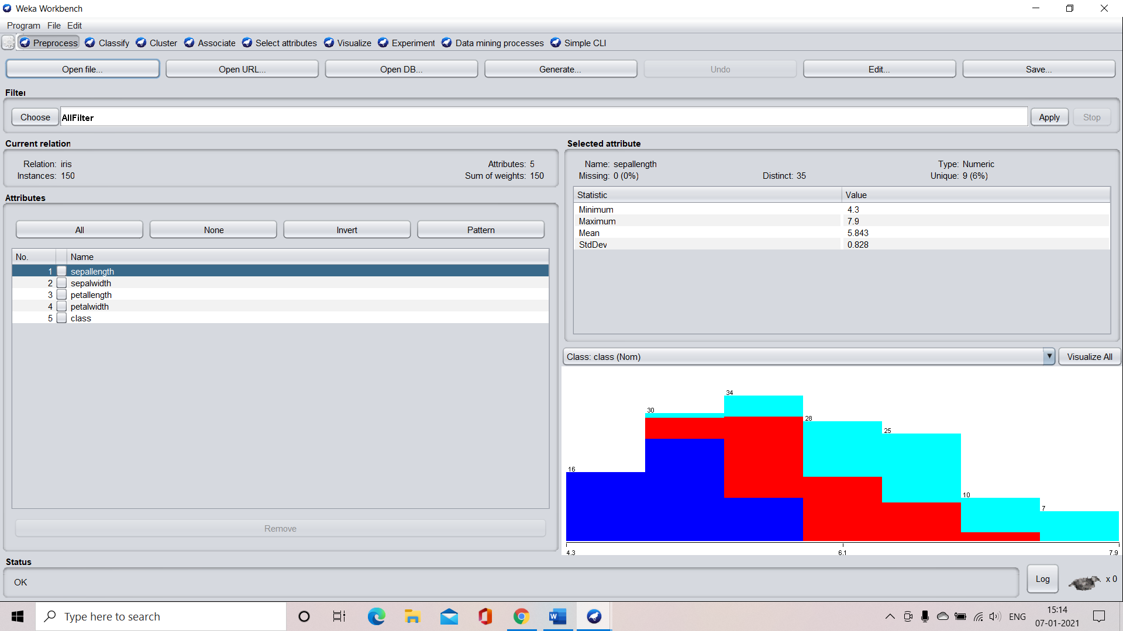

1. Number of attributes in the dataset : 5



1. Number of records in the dataset: 150



1. Class attribute in the dataset – class

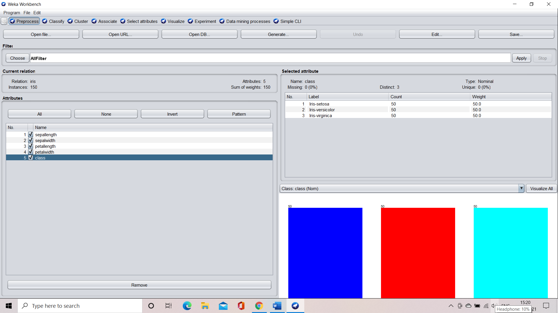

1. Number of records for each class:

* Iris-setosa – 50
* Iris-verginica – 50
* Iris-versicolor – 50



1. Graphical representation of all attributes against class attribute

